Convergence tests

Aim: understand the effect of changing the range of values included in the mass function:

What would be good to present as a record of the convergence tests?
- Plots comparing the results for f_PBH of the different tests
  - Fractional difference between the most accurate version and less precise versions
- Data stored for each of the convergence tests
  - This is done in the Isatis results file
- Plots comparing the mass function at formation compared to the evolved mass function
- Program comparing the results obtained using different levels of accuracy
  - This could be written fairly straightforwardly by looping through different values of the cutoff, and the range of masses, and

How should I handle the total number of PBHs to include?
Include (one of) the following in the results saved from isatis_runner.py:

Number of PBHs simulated (or spacing of the PBHs in log_10(m / grams), see comment below)
- To file names, append “logNBH={:.0f}”.format(BH_number

If the range of masses for which psi(m) / m^3 is non-negligible differs significantly between MFs and/or values of Delta, may be better to use a constant spacing of PBH masses in log_10(m) rather than a fixed number of PBHs, so that for each MF the integrand is sampled at a sufficient number of points
- Calculate
  - BH_number = int((np.log10(m_upper_X[i]) – np.log10(m_lower_X[i])) / delta_m)
  - delta_m = spacing of PBH masses in log10(m / grams)
- Save filenames with “dlogm={:.0f}”.format(delta_m)
- I am thinking this approach would be better, since it is clearly true that the mass range for which the MF is non-negligible varies significantly between different Deltas.

What should the cutoff be in terms of?
- 1e-3, 1e-5, 1e-7 (for psi(M) / psi_max)
- 1e-3, 1e-5, 1e-7 (for [psi(M) / M^3] / max[psi(M) / M^3])
- Understand whether psi(M) / M^3 is the right measure
- It is, when neglecting secondary emission of photons from
- Consider the effect of including evaporation on the MF
- Comment: the in 2009.03204 are for muti-solar mass PBHs, for which the effect of evaporation is negligible, hence the mass function is essentially unchanged from the formation mass function (neglecting evaporation, mergers etc.)
- On the other hand, when applied to the asteroid-mass range, the MFs will be modified due to the effects of PBH evaporation
- Read through CKSY ‘16 sections on this

Which Delta(s) to focus on?
When considering a cutoff in terms of psi(M) / psi_max
- Larger Delta? For a given M_c:
  - In the mass function psi / psi_max here will be a larger contribution from low-mass PBHs in the low-mass tail
  - This argument applies for both the mass function itself and the mass function * photon emission rate

Which mass functions to focus on?
- Ideally, include results for each MF and each Delta

Save data for f_PBH?
- Yes, for each convergence test

How to save file names and sort these?

- Save the following data with a clear name:

  - Include the power of the cutoff
    - i.e. if the cutoff is 10^{-c}, with c=5, append “c=5” to filename

  - Include the quantity that is being used to determine the cutoff
    - “MF” for the cutoff applied to the mass function (at formation) scaled to its peak value (psi / psi_max)
    - “integrand” for the cutoff applied to the mass function (at formation) / mass^3, matching
    - “integrand2” for the cutoff applied to the present-day mass function (accounting for Hawking evaporation) / mass^3
____________________________________________________________________________
METHODS: (to appear in preliminaries.py)
- integrand_measure (m, m_f, params)
  - Approximate form of the integrand appearing in Eq. 11 of 2201.01265.
  - m:
    - Array-like. PBH mass.
  - m_c :
    - Float. Characteristic PBH mass (m_c for a (skew-)lognormal, m_p for CC3).
  - mf:
    - PBH mass function.
  - params:
    - Array-like. Parameters of the PBH mass function.
  - Returns:
    - Array-like: PBH mass function divided by mass cubed, scaled so that the maximum value is one.

____________________________________________________________________________
Galactic Centre photon constraints: Convergence tests

Currently, I am varying two quantities:
- PBH mass range
- Spacing between each PBH across the mass range

To consider:
- Number of energies at which the constraint is calculated
- 23/3: isatis_runner.py allows constraint to be calculated using multiple values of the number of energies.

To consider for comparison:
- Have the ability to plot the constraints. This makes sure that if there is a large disagreement outside of the mass range for which f_PBH < 1, this does not lead me to think that there is a more significant disagreement than there is
- The effect of having a larger PBH mass range is likely to have a strongest effect on large Delta, so I should focus on larger Delta when understanding the difference between the constraints.
- For all the comparisons, use a “benchmark” which is the most accurate
  - In the notation I’m using for the filenames, this is the largest c and dm value (since these are given by the exponent of 1e-c and 1e-dm, respectively)

- Loop through values of Delta

  - Load results for the most accurate constraint (smallest cutoff, smallest spacing), and denote this “f_PBH_benchmark”

  - Find the envelope of constraints from f_PBH_benchmark

  - Create a figure

  - Loop through values of the cutoff

    - Loop through values of the PBH mass spacing dm

    - Load results for each cutoff and dm

    - Find envelope of the constraints

    - Calculate the fractional difference between the envelope of the constraints and the envelope of the benchmark constraint

    - Plot the fractional difference. Include labels giving the cutoff and spacing

    - How to understand this as a change of the constraint to a given number of significant figures?

  - Other plot details (axis limits, labels etc.)

To do: perform similar tests for the Subaru-HSC constraints, with the number of BHs varying

23/3

Added loops into isatis_runner.py over:
- Cutoff
- PBH mass spacing dm
- Number of energies to use

Results for M_c = 1e19g, E_number=1000:

- See Convergence tests_outline.ods

- The results indicate that a spacing dm=3 and cutoff=1e-3 is sufficient (i.e. the results for f_PBH agree to within 2SF of the value given by the most precise results), with the exception of the Delta=5.0 result for the SLN MF.
  - I think I understand why the SLN is worse than the CC3 for Delta=5.0.
    - For Delta = 5.0, the SLN fit is more positively skewed than the CC3 fit to the MF (the CC3 generally struggles to produce positive skew, as discussed in the conclusion of 2009.03204)
    - Therefore, using the cutoff in terms of the MF is worse for the SLN MF than for the CC3 MF
  - For small Delta, I might expect the opposite to occur (this may affect smaller M_c).

- Two of the runs have problems
  - SLN with Delta=5.0, cutoff=1e-5, spacing dm=(1e-5)
    - All f_PBH results = 0 (not -1 or empty, which would indicate no constraint placed or a missing file, respectively)
  - SLN with Delta=5.0, cutoff=1e-7, spacing dm=(1e-5)
    - Run is killed by the terminal consistently
    - Number of BHs included
      - SLN, dm = 1e-5, cutoff=1e-5: BH_number = 769059
      - SLN, dm = 1e-5, cutoff=1e-7: BH_number = 925135
      - CC3, dm = 1e-5, cutoff=1e-7: BH_number = 922830
      - => possible that the issue arises from the number of PBHs being used

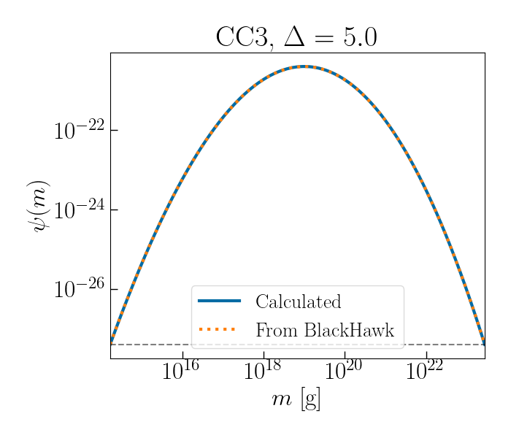

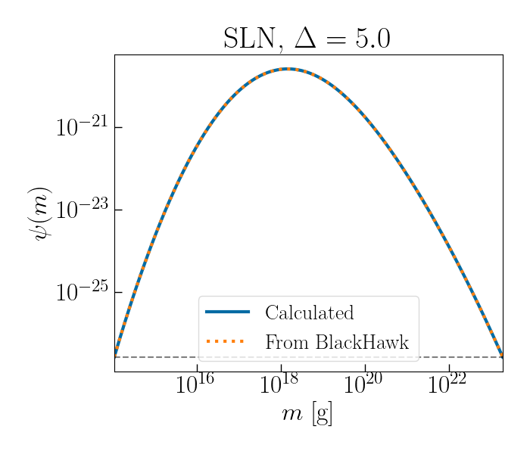

To do:
- Sanity checks:
  - Plot the MF (from the mass spectrum file) for a few cases, compare to what a SLN and CC3 MF should look like with those parameters
  - Compare where the MF (from the mass spectrum file) equals the cutoff as determined by the plot
  - See results from sanity_check_convergence_tests.py
    - All cases satisfy the sanity check.

Issue with all f_PBH = 0 (fixed):
- When trying to diagnose the cases for the runs which faced problems, I accidentally re-ran the dm=1e-4, cutoff =1e-7, Delta=5.0, MF=SLN, E_number = 1000 results.
  - All f_PBH results = 0 (not -1 or empty, which would indicate no constraint placed or a missing file, respectively)
  - When I had run this previously, it had given a finite value f_PBH = 68.933
- Checks
  - The results pass the mass function comparisons from sanity_check_convergence_tests.py
- Difference(s) from previous run:
  - Instead of running the results for all Delta, I am trying to restrict to Delta = 5.0 by including an if statement:
    - if i < 6:
    - pass
    - The reason for using an if statement here is that the loop over Deltas is an enumerate loop, and the value of the index is relevant
  - I commented out a few print statements and calculations that I had added to isatis_modified.c, and recompiled Isatis afterwards
    - I think re-compiling Isatis may have been the main problem.
    - After installing BlackHawk, I had made the following changes:
      - Changed line 1697 to remove a -1
      - Uncommented line 2007 (to ensure output results do not equal zero in each case)
      - Added several comments
    - I changed the name of the edited Isatis file to isatis_modified.c, and copied over an unmodified version of the file isatis.c
      - When I re-compiled Isatis today, it compiled the unmodified isatis.c, without the modifications needed.
      - When I removed the print statements, I saw no print statements appear and assumed I’d done everything correctly. Actually, this was a sign I was using the unmodified isatis.c without the changes needed to make it work correctly.
    - In isatis.c, I have changed line 1697 to remove a -1 and uncommented line 2007
- After correcting the issue with Isatis
  - The dm=1e-4, cutoff =1e-7, Delta=5.0, MF=SLN, E_number = 1000 results, give a finite value for f_PBH (and the same value as before)

Uncomment line 2007 in isatis.c installed on the PC: this would explain why all results equal zero.

Running with E_number = 10000
- I have removed all equals signs from file names, so that I can save log10(E_number) in the file name without causing truncationcond
- The truncation would be important in this case, since it cuts off the final digit of np.log10(M_c), which I would want to vary.

NOTE:
- I have checked that the results running on the PC match those that I obtained from the laptop, where they overlap.

Plots
See https://www.evernote.com/shard/s463/nl/233603521/f9dfcc9c-cfad-65e9-247e-066e0c375344?title=Convergence%20tests:%20summary

Source of plots: v2/Convergence_tests/Galactic_Centre

____________________________________________________________________________
Subaru-HSC constraints: Convergence tests

To perform a convergence test [INITIAL IMPLEMENTATION]

- Run WebPlotDigitizer with different spacings Delta X = Delta Y (in the “Averaging window” algorithm)

- Calculate the constraint for an extended MF, using the method from 1705.05567

  - For the most accurate version (smallest Delta X)

  - For the other Delta X values

- Calculate the fractional difference between the most accurate version and each constraint

NOTE: The minimum physical value to use for the Averaging window algorithm (when using Delta X = Delta Y) is 5 px, since otherwise the algorithm picks out multiple points at the same x and y of the line due to the finite width of the line. One can obtain smaller separation on the x-axis by increasing the height allowed Delta Y (e.g. for Delta X = 2px, Delta Y = 20 px).

- See the plot below, which shows that for Delta X = Delta Y < 5 px, the crosses ‘jump’ around due to the Averaging Window algorithm picking out multiple data points in the line. Zoom-in focuses on the upper end of the asteroid-mass window, the region relevant to this project.
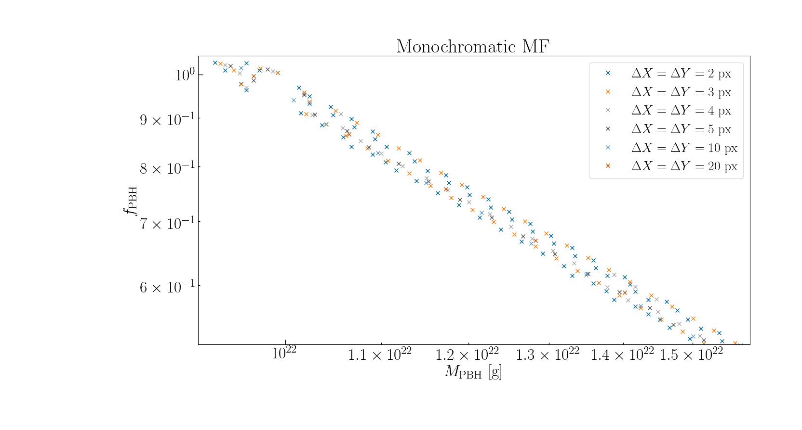

Results (preliminary):
“most” implies ~90%, “almost all” implies >~ 90%

LN:
- Delta = 0.0
- In lines 30-64:
- (Delta X = Delta Y = 5px) and (Delta X = 2 px, Delta Y = 20px) agree to 2SF.
- (Delta X = Delta Y = 10px) and (Delta X = 2 px, Delta Y = 20px) agree to 2SF in almost all cases.

SLN:
- Delta = 0.0
- In the range where f_PBH < 1:
- (Delta X = Delta Y = 5px) and (Delta X = 2 px, Delta Y = 20px) agree to 2SF in almost all cases.
- (Delta X = Delta Y = 10px) and (Delta X = 2 px, Delta Y = 20px) agree to 2SF in almost all cases.
- (Delta X = Delta Y = 20px) and (Delta X = 2 px, Delta Y = 20px) agree to 2SF in most cases.

- Delta = 2.0
- In the range where f_PBH < 1:
- (Delta X = Delta Y = 5px) and (Delta X = 2 px, Delta Y = 20px) agree to 2SF in almost all cases.
- (Delta X = Delta Y = 10px) and (Delta X = 2 px, Delta Y = 20px) agree to 2SF in most cases
- (Delta X = Delta Y = 20px) and (Delta X = 2 px, Delta Y = 20px) agree to 2SF in most cases.

CC3:
- Delta = 0.0
- In the range where f_PBH < 1:
- (Delta X = Delta Y = 5px) and (Delta X = 2 px, Delta Y = 20px) agree to 2SF in almost all cases.

- Delta = 2.0
- In the range where f_PBH < 1:
- (Delta X = Delta Y = 5px) and (Delta X = 2 px, Delta Y = 20px) agree to 2SF in almost all cases.
- (Delta X = Delta Y = 10px) and (Delta X = 2 px, Delta Y = 20px) agree to 2SF in almost all cases.
- (Delta X = Delta Y = 20px) and (Delta X = 2 px, Delta Y = 20px) agree to 2SF in almost all cases.

20/3:
- I have written two methods to calculate the number of data points that agree to a given number of n SF, comparing two arrays
- Try to rewrite method to allow the number of SF to be inputted as a variable, rather than hard-coded.
- Add docstrings.

